NAME ……………………………………..……… ……………..DATE …………………………………

INDEX NO. …………….……….……..…..… CANDIDATE’S SIGNATURE ………….

451/1
COMPUTER STUDIES
PAPER 1
(THEORY)
TIME: 2 ½ hours

FORM FOUR EXAMINATION 2025

451/1
COMPUTER STUDIES
PAPER 1
(THEORY)
TIME: 2 ½ hours

Instructions to Candidates
- Write your name and index number in the spaces provided above.
- This Paper consists of two sections A and B.
- Answer ALL the questions in section A.
- Answer question 16 (compulsory) and any other THREE questions from section B.
- All answers should be written in the spaces provided.
- This paper consists of 13 printed pages. Candidates should check to ensure that all pages are printed as indicated and no questions are missing

FOR EXAMINER’S USE ONLY
Section | Questions | Candidate’s score
A | - 15
B | 16
B | 17
B | 18
B | 19
B | 20
B | TOTAL SCORE

SECTION A (40MARKS) – ANSWER ALL QUESTIONS IN THIS SECTION
- State two health issues that could arise from the use of unsuitable computer desk (2 marks)

………………………………………………………………………………………………………………………………………………………………………………………………………………………………………………………………………………………………………………………………………
- Give two reasons why portable computers like laptops and tablets are becoming popular in the modern society (2 marks)

……………………………………………………………………………………………………………………………………………………………………………………………………………………………………………………………………………………………………………………………………………………………………………………………………………………………………………………
- Warranty is one of factors to put into consideration when acquiring computer hardware. State two contents of a warranty (2 marks)

……………………………………………………………………………………………………………………………………………………………………………………………………………………………………………………………………………………………………………………………………………………………………………………………………………………………………………………
- List four devices that use scanning technology to capture data directly from the source (2 marks)

……………………………………………………………………………………………………………………………………………………………………………………………………………………………………………………………………………………………………………………………………………………………………………………………………………………………………………………
- State two ways in which hardware failure is a threat to data security (2 marks)

…………………………………………………………………………………………………………………………………………………………………………………………………………………………

- Given the binary number 1101110100111100 , determine the number of :
- Nibbles (1 mark)

…….……………………………………………………………………………………………………
- Bytes (1mark)

…………………………………………………………………………………………………………
- (a) State the role of the following communication devices
- Repeater (1 mark)

…………………………………………………………………………………………………………………………………………………………………………………………………………………………
- Router (1 mark)

…………………………………………………………………………………………………………………………………………………………………………………………………………………………
(b) The figure below shows a type of network topology. Use it to answer the questions that follow;

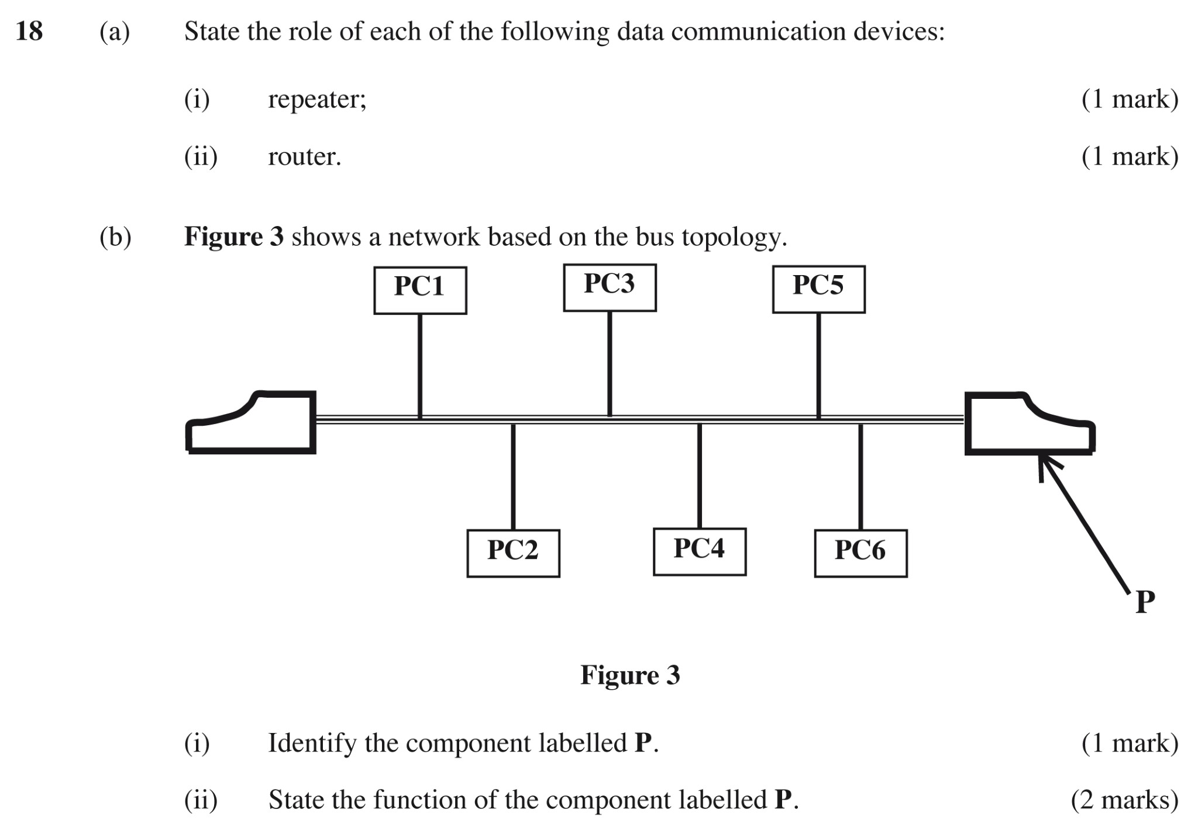

- Identify the topology represented above (1 mark)
………………………………………………………………………………………………………………
- Name the component labelled P (1 mark)
………………………………………………………………………………………………………………

- State the function of the component labelled P (1 mark)
…………………………………………………………………………………………………………………………………………………………………………………………………………………………
- Five students Walter, Faith, Mercy, Diana and Joachim scored the following marks in Mathematics 35, 76, 98, 44, and 54 respectively. They were recorded in cell C3 to C7. The teacher wanted to rank them in descending order so as to award them
- Write down an appropriate formula that the teacher used (3marks)

- Their grades were assigned as follows
80-100 ……………. A
60-79 ………………B
40-59 ………………C
Less Than 40 ……..Fail
Write the formula used to assign the grades above (2marks)

- Differentiate between hardware and software portability (2marks)
………………………………………………………………………………………………………………………………………………………………………………………………………………………………………………………………………………………………………………………………………………

- Differentiate between formatting and editing as used in word processor (2 marks)
………………………………………………………………………………………………………………………………………………………………………………………………………………………………………………………………………………………………………………………………………
- Explain the meaning of the following terms as used with DTP (3 marks)
- Crop
………………………………………………………………………………………………………………………………………………………………………………………………………………………………
- Embedded object
………………………………………………………………………………………………………………………………………………………………………………………………………………………………
- Master page
………………………………………………………………………………………………………………………………………………………………………………………………………………………………
- Explain the following as used in data security (3marks)
- Fraud
………………………………………………………………………………………………………………………………………………………………………………………………………………………………
- Eavesdropping
………………………………………………………………………………………………………………
………………………………………………………………………………………………………………
- Information security
………………………………………………………………………………………………………………
………………………………………………………………………………………………………………

- Distinguish between relative cell referencing and absolute cell referencing as used in computing giving an example in each case (4 marks)

……………………………………………………………………………………………………………………………………………………………………………………………………………………………………………………………………………………………………………………………………………………………………………………………………………………………………………………
- Explain the following monitor terminologies as used in computing. (3 marks)
- Resolution

……………………………………………………………………………………………………………………………………………………………………………………………………………………….
- Pixels
…………………………………………………………………………………………………………………………………………………………………………………………………………………………
- State four stages in data processing (2 marks)
………………………………………………………………………………………………………………………………………………………………………………………………………………………………………………………………………………………………………………………………………………
………………………………………………………………………………………………………………

SECTION B (60MARKS)
Answer question 16 (compulsory) and any other THREE question from this section
- a) Explain three errors detecting methods in program development (3marks)
………………………………………………………………………………………………………………………………………………………………………………………………………………………………………………………………………………………………………………………………………………
b) The gross salary of employees of Mutson chemists is based on the basic and additional benefits. Employees with more than 10 years’ experience get an additional pay of 10% of their basic salary. Bonuses are given as per employees’ sales of the month as:
>200,000 15%
100,000 – 200,000 10%
Below 100,000 5%
Draw a flowchart for the program that will calculate gross salary and output each employee’s basic
salary, gross salary and all benefits. (12marks)

- a) State two ways of representing a signed binary number. (2 marks)
………………………………………………………………………………………………………………………………………………………………………………………………………………………………………………………………………………………………………………………………………………
b) Convert the decimal number 7.03125₁₀ to binary (3 marks)

- Perform the following binary operation; (2 marks)
X₂+1101₂=70₁₀

- Solve the following using twos complement 12₁₀-28₁₀ (5 marks)

e ) i) Letter N is represented by 1001110 using a certain coding scheme. Identify the type of coding scheme used (1 mark)
……………………………………………………………………………………………………………………
ii) Using the same coding scheme named in C (i) above, show how letter K can be represented (2 marks)

- Describe each of the following data processing methods and give an example of where used. (4 marks)
- Online processing
………………………………………………………………………………………………………………………………………………………………………………………………………………………………………………………………………………………………………………………………………………
- Batch processing
………………………………………………………………………………………………………………………………………………………………………………………………………………………………………………………………………………………………………………………………………………
b) Make a clear difference between (4marks)
- Logical file and physical file
………………………………………………………………………………………………………………………………………………………………………………………………………………………………………………………………………………………………………………………………………………
- Master file and back up file
………………………………………………………………………………………………………………………………………………………………………………………………………………………………………………………………………………………………………………………………………………

c) An organization is facing threats to data integrity. Explain three ways on of how the threats can be
minimized (3marks)

………………………………………………………………………………………………………………………………………………………………………………………………………………………………………………………………………………………………………………………………………

d) Write the following acronyms in full
- EBCOIC (1 mark)
………………………………………………………………………………………………………………………………………………………………………………………………………………………………
- COBOL (1 mark)
………………………………………………………………………………………………………………………………………………………………………………………………………………………………
- ASCII (1 mark)
………………………………………………………………………………………………………………………………………………………………………………………………………………………………
(iv) BCD (1 mark)
………………………………………………………………………………………………………………………………………………………………………………………………………………………………
19. The table below shows an extract of a spreadsheet document. Use it to answer the following questions.
 | A | B | C | D | E | F
1 | ITEM NAME | NUMBER OF ITEMS | UNIT COST | TOTAL BUYING PRICE | TOTAL SELLING PRICE | PROFIT
2 | PENS | 50 | 25 |  |  | 100
3 | BOOKS | 15 | 70 |  |  | 750
4 | CUPS | 30 | 120 |  |  | 500
5 | RUBBER | 75 | 15 |  |  | 250

- What data type will be used to represent content of cell A1,C1 and E1? (3 marks)

………………………………………………………………………………………………………………………………………………………………………………………………………………………………
………………………………………………………………………………………………………………
- State how cell F5 can be represented using R1C1 style? (1 mark)

……………………………………………………………………………………………………………
- Which formula can be used to compute;
i) Buying price (1 mark)

ii) Profit (1 mark)

- Write a function that will enable you get the product with the max profit (2 marks)

- Explain the following editing tools in (4 marks)
- Label
…………………………………………………………………………………………………………………………………………………………………………………………………………………………
- Legend
…………………………………………………………………………………………………………………………………………………………………………………………………………………………
- Chart title
……………………………………………………………………………………………………………………………………………………………………………………………………………………….....
- Data markers
…………………………………………………………………………………………………………………………………………………………………………………………………………………………
- Explain the concept of subtotals (3 marks)
……………………………………………………………………………………………………………………………………………………………………………………………………………………………………………………………………………………………………………………………………………………………………………………………………………………………………………………
20.a) Which data communication are represented below ( 3marks)
- A police officer talking over a walkie talkie

……………………………………………………………………………………………………………
- A pastor speaking to Christians using public address

……………………………………………………………………………………………………………
- A student speaking to their parent over the mobile phone

……………………………………………………………………………………………………………
b) Explain the following application areas of ICT. (5 marks)

- Retail system

……………………………………………………………………………………………………………
……………………………………………………………………………………………………………
- Education system

……………………………………………………………………………………………………………
……………………………………………………………………………………………………………
- Transport System

……………………………………………………………………………………………………………
……………………………………………………………………………………………………………
iv) Scientific Research
……………………………………………………………………………………………………………
……………………………………………………………………………………………………………
v) Entertainment System
……………………………………………………………………………………………………………
……………………………………………………………………………………………………………

c) A teacher had a document of 20GB in a hard disk. He wanted to transfer the document into a CD of 700MB. Determine the number of CD’s he requires (2 marks)

- Students of Amani high school intend to elect their school captain by secret ballot. State two ways high computers can improve the election process (2 marks)

……………………………………………………………………………………………………………
……………………………………………………………………………………………………………
……………………………………………………………………………………………………………
……………………………………………………………………………………………………………
- The following URL was typed by Amina: (3 marks)
http://www.cie.org.uk/computer studies
The URL composed of three parts; state the part of the URL that represents:
- File name
………………………………………………………………………………………………………………………………………………………………………………………………………………………….
- Protocol

……………………………………………………………………………………………………………
……………………………………………………………………………………………………………
- Web server name

…………………………………………………………………………………………………………………………………………………………………………………………………………………………

©THIS IS THE LAST PRINTED PAGE

